Chapter 1

**Introduction**

* 1. **General Introduction**

Online shopping is the process whereby consumers directly buy goods, services etc. from a seller interactively in real-time without an intermediary service over the internet.

Online shopping is the process of buying goods and services from merchants who sells on the Internet. Since the emergence of the World Wide Web, merchants have sought to sell their products to people who surf the Internet. Shoppers can visit web stores from the comfort of their homes and shop as they sit in front of the computer. Consumers buy a variety of items from online stores. In fact, people can purchase just about anything from companies that provide their products online. Books, clothing, household appliances, toys, hardware, software, and health insurance are just some of the hundreds of products consumers can buy from an online store.

**1.2 Purposes**

Online shopping tries to enhance access to care and improve the continuity and efficiency of services. Depending on the specific setting and locale, case managers are responsible for a variety of tasks, ranging from linking clients to services to actually providing intensive shopping and delivery services themselves.

**1.3 Objectives:**

* To shop while comforting of our own home without having to step out of the door.
* Sell at lower rate due to less overhead.
* No wait to see the products if someone else are taking that.
* It saves time.

**1.4 Advantages of our site:**

* Saves time
* Saves energy
* More variety
* Easy to find the products
* Shop any time anywhere in world
* Reduces transaction costs
* Price comparison
* Privacy
* No crowds

**1.5 Limitations of our site:**

* Time Consuming
* Currently don’t have much facilities to compare with other shops.
* Must be needed internet connection,
* It won’t work if either one of these two MySQL and PHP stop working or not installed.

Chapter 2

**System Analysis**

**2.1 Analyzing the system:**

This system is all about the converting the shopping-

* System from manual to online.
* Customer can buy products online after login to the site.
* Administrator is adding product to database.
* Administrator can edit or delete the products from the database.
* After buying and making payment the products are send to customers address.
* Customer can write feedback for the product or services.
* Admin can see daily sell and feedback given by customer.
* Administrator is adding the delivery report to the database.
* Both admin and customer can see the delivery report.

**2.2 Scope:**

This product has great future scope. Online shopping Internet software developed on and for the Windows and later versions environments and Linux OS. This project also provides security with the use of Login-id and Password, so that any unauthorized users can’t use any account. The only authorized (authorized) that will have proper access authority can access the software.

**2.3 Cost Estimation:**

An estimate is a prediction based upon probabilistic assessment. It is the responsibility of the project manager to make accurate estimations of effort and cost. This is particularly true for projects subject to competitive bidding where a bid too high compared with competitors would result in losing the contract or a bid too low could result in a loss to the organization. This does not mean that internal projects are unimportant. From a project leaders estimate the management often decide whether to proceed with the project. Industry has a need for accurate estimates of effort and size at a very early stage in a project. However, when software cost estimates are done early in the software development process the estimate can be based on wrong or incomplete requirements.

**2.4 Feasibility Study:**

A feasibility study is used to determine the viability of an idea, such as ensuring a project is legally and technically feasible as well as economically justifiable. It tells us whether a project is worth the investment.

**2.4.1 Technical Feasibility:**

This is concerned with specifying equipment and software that will successfully satisfy the use considerably, but might include

* + The feasibility to produce output in a given time because system is fast enough to handle multiple users.
  + Response time under certain circumstances and ability to process a certain volume of transaction of a particular speed.
  + Feasibility to communicate data to distant location.

**2.4.2 Financial Feasibility:**

Economic analysis is the most frequently used technique used for evaluating the effectiveness of a proposed system. More commonly known as cost/benefit analysis the procedure is to determine the benefits and savings that are expected from a proposed system and compared them with cost. Though the cost of installing the system may appear high, it is one time investment. The resulting benefits are that automation results in turnaround time. The resulting cost/benefit ratio is favorable.

**2.4.3 Operational Feasibility:**

It is mainly related to human organizational as social aspects. The points to be considered are the system interface is standard, user friendly and provides extensive help. Hence no special training is not required.

**2.4.4 Social Feasibility:**

Social feasibility is determination of whether a proposed project will be acceptable to people or not, so this project is totally Social and Feasible.

Chapter 3

**System Requirements**

**3.1 User Class and Characteristics:**

There are 3 types of user of this software-

1. General user
2. Customers
3. Administrator

**General user:**

* They can use the system to see the product, their prices and quantity available.
* General user can’t buy the products.

**Customers:**

* Customers are using for viewing and buying the products. Customer can also write feedbacks for products and services.

**Administrator:**

* Admin can add, edit & delete products and provide services to the customer.
* Administrator can see the daily sell.
* Administrator maintaining the deliveries.

**3.2 Functional Requirements:**

The System must provide following functionalities—

* Keeping records of customers.
* Keeping the records of products.
* Keeping the daily sell.
* Storing the feedback given by the customer.
* Keeping details about the product it is delivered or not etc.
* Storing the items selected by the customer in the temporary storage.

**3.3 Non Functional Requirements:**

Following Non-functional requirements will be there in the Insurance on internet:

1. Secure access of confidential data (customer’s details).
2. 24 X 7 availability.
3. Better component design to get better performance at peak time.
4. Flexible service based architecture will be highly desirable for future extension nonfunctional requirements define system properties and constraints. It arise through user needs, because of budget constraints or organizational policies, or due to the external factors such as safety regulations, privacy registration and so on.

Various other Non-functional requirements are:

1. Security
2. Reliability
3. Maintainability
4. Portability
5. Extensibility
6. Reusability

**3.4 Performance Requirements:**

In order to maintain an acceptable speed at maximum number of uploads allowed from a particular customer will be any number of users can access the system at any time. Also connections to the servers will be based on the criteria of attributes of the user like his location, and server will be working whole 24X 7 times.

**3.5 External Interfaces Requirements:**

**3.5.1 Hardware Interface:**

Hardware requirements for Insurance on internet will be same for both the parties which are:

1. Processor : Intel core i5
2. RAM : 4 GB
3. HD : 20 GB or above.

**3.5.2 Software Interface:**

Software required to make working of product are:

* 1. Operating System: Linux
  2. PHP 5.6
  3. MySQL
  4. HTML, CSS & JavaScript

Chapter 4

**Design Specification**

**4.1 System Design:**

System design is the solution for the creation of a new system. This phase focuses on the detailed implementation of the feasible system. It emphasis on translating design. Specifications to performance specification. System design has two phases of development

* Logical design
* Physical design

**Logical Design:** During logical design phase the analyst describes inputs, outputs, databases, procedures all in a format that meets the user requirements. The analyst also specifies the needs of the user at a level that virtually determines the information flow in and out of the system and the data resources. Here the logical design is done through data flow diagrams and database design.

**Physical Design:** The physical design is followed by physical design or coding. Physical design produces the working system by defining the design specifications, which specify exactly what the candidate system must do. The programmers write the necessary programs that accept input from the user, perform necessary processing on accepted data and produce the required report on a hard copy or display it on the screen.

**4.2 Admin Interface:**

The admin is the super user of this application. Only admin has access into this admin page. Admin may be the owner of the shop. The admin has all the information about all products.

The admin can manages the products and orders that is made by the customers.

Sign in

Manage

Order

Manage

Products

**Admin**

Fig 4.1: Admin interface

1. **Admin Sign in:** The admin starts this action by inputting the username and password and clicking on the submitbutton. The page is sent the message to the server to validate the information from the database. After successful validation, the logged in page is returned with options for the admin to add, modify, or delete products.
2. **Manage Products:**

Admin

Edit

Products

Add Products

Delete

Products

Fig4.2: Admin manage products

* **Add Products:** The products can be classified into different categories by name. Admin can add new products into the existing system with all its details including an image. Once add button is clicked, the web page sends this information to the server, which in turns stores it in the database.
* **Edit Products:** Admin can edit or modify the products by clicking the Edit button. The web page is displayed a list available products from the database. The admin then chooses the item he/she wants to modify by clicking on particular item. A page is displayed letting the admin to modify all item information, the web page sends a message to the server, which updating the information from the database
* **Delete Products:** Administrator can delete the products based on the stock of that particular product. The admin starts this action by clicking on the Delete button. Once, delete button is clicked, the page is send message to the server which in turns tells the database to remove the item.

1. **Manage Order:**

Admin

Delete

Order

View

Order

Fig4.3: Admin manage order

* **View Order:** Admin can view the Orders which is generated by the users and also can verify the details of the purchase.
* **Delete Order:** Admin can delete the order if the order is already sent or the product that has been order is out of stock.

**4.3 User Interface:**

The user or customer can visit the shop without any registration but can’t buy their desired product without sign in to the site. After signing in they can buy their desired products.

User**/**Customer

Fig4.4: User Interface

1. **Registration:** A new user will have to register in the system by providing essential details in order to but the products in the system.
2. **Login:** A user must login with his user name and password to the system after registration.
3. **View Products:** User can view the list of products based on their names after successful login. A detailed description of a particular product with product name, products details, product image, and price can be viewed by users.
4. **Search Products:** The customer starts this action by typing a name into the search box for finding a product. The page sends a message to the server asking for a listing of products, whose names match the search, from the database. The action is complete when a page is returned for the customer to view, which contains a list of the resulting products along with their picture, price, and an option to add the product to the shopping cart. If a given description doesn’t match with any descriptions in the database, a message indicating such is displayed instead of the option to add to cart.
5. **Add products to cart:** The user can add the desired product into his cart by clicking add to cart option on the product. User can view the cart by clicking on the cart button. All products added by cart can be viewed in the cart. If the product already exists in the customer’s cart, its quantity is increased by 1.
6. **Remove Product:** User can remove an item from the cart by clicking remove.
7. **Check Out:** After confirming the items in the cart the user have to give his/ her phone number, transection id and delivery address. Then the user can check out. If it is successful then the cart will become empty.

**5.3 System Tools:**

A project development and an implementation technology can be mapped out using a project timeline. It is a process for defining designing, testing, and implementation of a software application or program. Acquisition of their party tools like dependency manager, database system all can be included for customizing the total system.

Tools that we have used to design and develop our system are as follows-

* **HTML:**

It is used to generate web page. HTML, an initialization of Hypertext Markup Language, is the predominant [markup language](http://en.wikipedia.org/wiki/Markup_language) for [web pages](http://en.wikipedia.org/wiki/Web_page). It provides a means to describe the structure of text-based information in a document — by denoting certain text as headings, paragraphs, lists, and so on.

* **CSS:**

CSS stands for “Cascading Style Sheets” is a language for style and manipulate HTML Language. CSS is a style sheet language used for describing the look and formatting of a document written in a markup language.

* **PHP:**

PHP is a technology that lets you mix regular, static HTML with dynamically-generated HTML. Many Web pages that are built by CGI programs are mostly static, with the dynamic part limited to a few small locations. But most CGI variations, including servlets, make you generate the entire page via your program, even though most of it is always the same.

* **JavaScript:**

JS is a dynamic computer programming language. It is most commonly used as part of web browsers, whose implementations allow client-side scripts to interact with the user, control the browser, communicate asynchronously, and alter the document content that is displayed. Java Script is used to create popup windows displaying different alerts in the system like “User registered successfully” , ”Product added to cart” etc.

* **MySQL:**

MySQL is a [relational database management system](http://en.wikipedia.org/wiki/Relational_database_management_system) (RDBMS) which has more than 6 million installations. MySQL stands for "My Structured Query Language". The program runs as a server providing multi-user access to a number of databases.

* **Bootstrap:**

Bootstrap is free open source front end web framework that is used to design websites and web applications. HTML and CSS is used to create Bootstrap framework. It makes the web interfaces more user friendly.

**5.3 Data Flow diagram:**

A Data Flow Diagram (DFD) is a structured analysis and design tool that can be used for flowcharting. A DFD is a network that describes the flow of data and the processes that change or transform the data throughout a system. This network is constructed by using a set of symbols that do not imply any physical implementation. It has the purpose of clarifying system requirements and identifying major transformations. So it is the starting point of the design phase that functionally decomposes the requirements specifications down to the lowest level of detail. DFD can be considered to an abstraction of the logic of an information-oriented or a process-oriented system flow-chart. For these reasons DFD’s are often referred to as logical data flow diagrams.

**5.3.1 Data Flow:**

The data flow shows the flow of information from a source to its destination. Data flow is represented by a line, with arrowheads showing the direction of flow. Information always flows to or from a process and may be written, verbal or electronic. Each data flow may be referenced by the processes or data stores at its head and tail, or by a description of its contents.

**Admin DFD:**

Add Category

Category

Tabl

e

DB

Manage categories

Edit Category

Delete Category

Add Products

Admin

Sign in

Manage Products

Products

Table

DB

Edit Products

Delete Products

Manage Orders

View Order

Order

Table

DB

Delete Order

Fig 4.1: Admin DFD

**Customer DFD:**

Search Product

Product Table

DB

Customer

Buy Products

Sign in

Registration

Remove product

Add to Cart

View Products

Quantity change

Bill/Ship

Order

Table DB

Check

Out

Fig 4.2: Customer DFD

**5.4 Database Design:**

A database design is a collection of stored data organized in such a way that the data requirements are satisfied by the database. The general objective is to make information access easy, quick, inexpensive and flexible for the user. There are also some specific objectives like controlled redundancy from failure, privacy, security and performance.

A collection of relative records make up a table. To design and store data to the needed forms database tables are prepared. Two essential settings for a database are:

* **Primary key**: The field that is unique for all the record occurrences.
* **Foreign key:** The field used to set relation between tables. Normalization is a technique to avoid redundancy in the tables.

**Database table Design**

Sign in Table

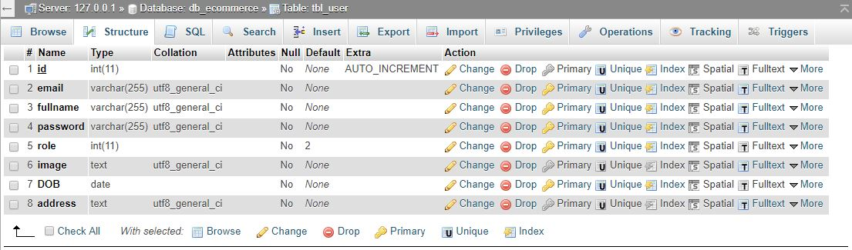

Category Table

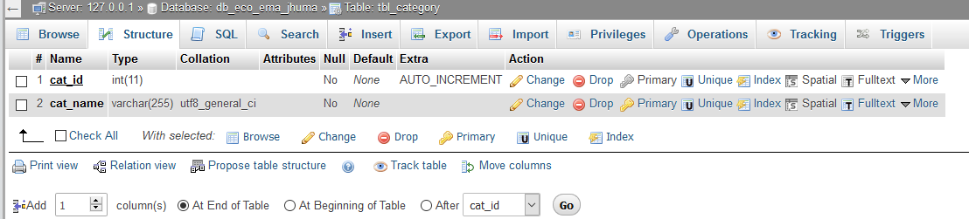

Products table

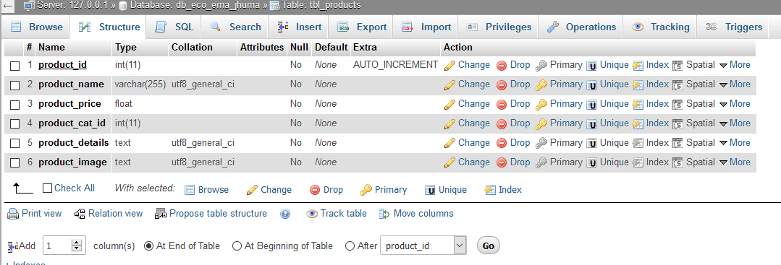

Order Table

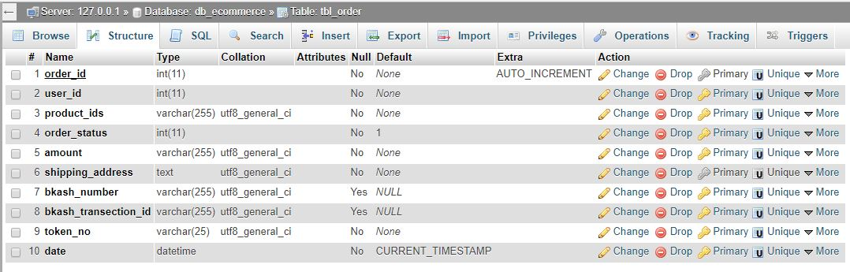

Chapter 5

**Implementation & Testing**

**5.1 Implementation:**

Implementation is the realization of an application, or execution of a plan, idea, model, design, specification, standard, algorithm, or policy. I worked so hard to implement this project. I use system implementation and website implementation.

**5.2 System Implementation:**

Systems implementation is the process of:

1. Defining how the information system should be built
2. Ensuring that the information system is operational and used,
3. Ensuring that the information system meets quality standard.

For implementation of a website:

1. The website can be installed on a server which has PHP and MYSQL installed in it.
2. The owners of the website are to be properly trained to use all the features of the website.
3. To show the accuracy of the website and conformance of the owners or users.

**5.3 Testing:**

Software testing is the process used to measure the [quality](http://en.wikipedia.org/wiki/Software_quality) of developed [computer software](http://en.wikipedia.org/wiki/Computer_software). Usually, quality is constrained to such topics as [correctness](http://en.wikipedia.org/wiki/Correctness), completeness, [security](http://en.wikipedia.org/wiki/Computer_security_audit), but can also include more technical requirements as described under the [ISO](http://en.wikipedia.org/wiki/International_Organization_for_Standardization) standard [ISO 9126](http://en.wikipedia.org/wiki/ISO_9126), such as capability, [reliability](http://en.wikipedia.org/wiki/Reliability), [efficiency](http://en.wikipedia.org/wiki/Algorithmic_efficiency), [portability](http://en.wikipedia.org/wiki/Porting), [maintainability](http://en.wikipedia.org/wiki/Maintainability), compatibility, and [usability](http://en.wikipedia.org/wiki/Usability). Testing is a process of technical investigation, performed on behalf of stakeholders, that is intended to reveal quality-related information about the product with respect to the context in which it is intended to operate.

**5.3.1 Black box testing:**

It treats the software as a black-box without any understanding as to how the internals behave. Thus, the tester inputs data and only sees the output from the test object. This level of testing usually requires thorough test cases to be provided to the tester who then can simply verify that for a given input, the output value (or behavior), is the same as the expected value specified in the test case.

**5.3.2 White box testing:**

It is when the tester has access to the internal data structures, code, and algorithms. For this reason, [unit testing](http://en.wikipedia.org/wiki/Unit_testing) and debugging can be classified as white-box testing and it usually requires writing code, or at a minimum, stepping through it, and thus requires more skill than the black-box tester. If the software in test is an interface or API of any sort, white-box testing is almost always required.

**5.3.3 Gray box testing:**

Grey box testing is the combination of black box and white box testing. Intention of this testing is to find out defects related to bad design or bad implementation of the system.it is used for web application.

**5.3.4 Unit Testing:**

The primary goal of unit testing is to take the smallest piece of testable software in the application, isolate it from the remainder of the code, and determine whether it behaves exactly as you expect. Each unit is tested separately before integrating them into modules to test the interfaces between modules. Unit testing has proven its value in that a large percentage of defects are identified during its use.

Unit testingis a software verification and validation method where the programmer gains confidence that individual units of source code are fit for use. A unit is the smallest testable part of an application. In procedural programming a unit may be an individual program, function, procedure, etc., while in object-oriented programming, the smallest unit is a class, which may belong to a base/super class, abstract class or derived/child class.

**5.3.5 Integration Testing:**

Integration testing, also known as integration and testing (I&T), is a software development process which program units are combined and tested as groups in multiple ways. In this context, a unit is defined as the smallest testable part of an application. Integration testing can expose problems with the interfaces among program components before trouble occurs in real-world program execution. Integration testing is a component of Extreme Programming (XP), a pragmatic method of software development that takes a meticulous approach to building a product by means of continual testing and revision.

There are two major ways of carrying out an integration test, called the bottom-up method and the top-down method. Bottom-up integration testing begins with unit testing, followed by tests of progressively higher-level combinations of units called modules or builds. In top-down integration testing, the highest-level modules are tested first and progressively lower-level modules are tested after that. In a comprehensive software development environment, bottom-up testing is usually done first, followed by top-down testing.

**5.3.6 Validation testing:**

At the validation level, testing focuses on user visible actions and user recognizable output from the system. Validations testing is said to be successful when software functions in a manner that can be reasonably expected by the customer. Two types of validation testing-

* **Alpha testing:** is simulated or actual operational testing by potential users/customers or an independent test team at the developers' site. Alpha testing is often employed for off-the-shelf software as a form of internal acceptance testing, before the software goes to beta testing.
* **Beta testing:** comes after alpha testing. Versions of the software, known as beta version, are released to a limited audience outside of the programming team. The software is released to groups of people so that further testing can ensure the product has few faults or bugs. Sometimes, beta versions are made available to the open public to increase the feedback field to a maximal number of future users.

**5.4 System Maintenance:**

Maintenance means restoring something to its original conditions. Enhancement means adding, modifying the code to support the changes in the user specification. System maintenance conforms the system to its original requirements and enhancement adds to system capability by incorporating new requirements.

Thus, maintenance changes the existing system, enhancement adds features to the existing system, and development replaces the existing system. It is an important part of system development that includes the activities which corrects errors in system design and implementation, updates the documents, and tests the data.

### 5.4.1 Types of Maintenance:

System maintenance can be classified into three types −

* **Corrective Maintenance** − Enables user to carry out the repairing and correcting leftover problems.
* **Adaptive Maintenance** − Enables user to replace the functions of the programs.
* **Perfective Maintenance** − Enables user to modify or enhance the programs according to the users’ requirements and changing needs.

Chapter 6

**Screenshots**

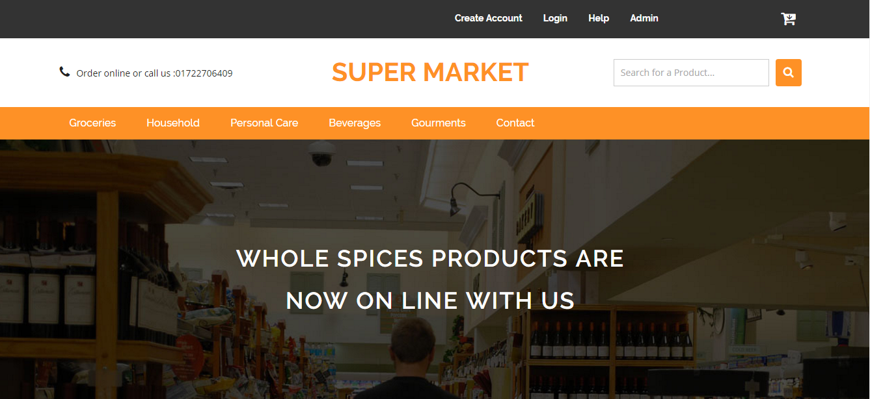

Homepage

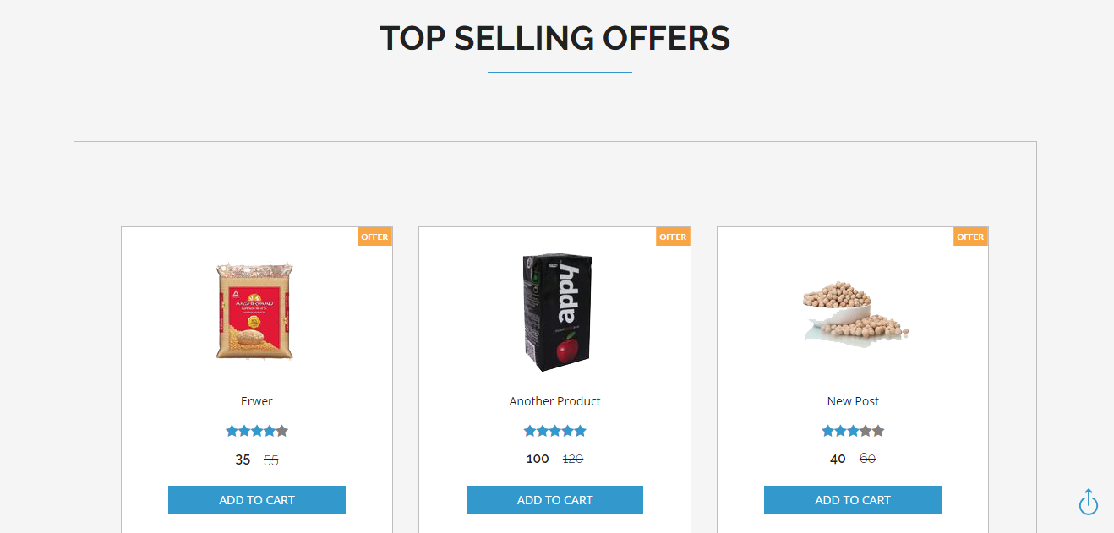

Products

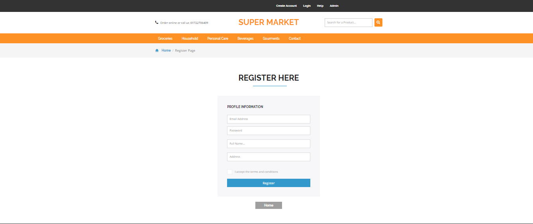

Sign up

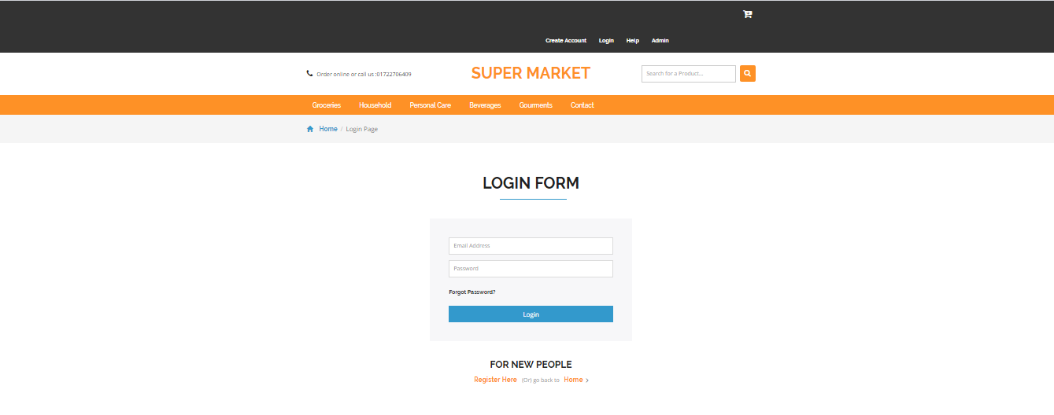

Sing in

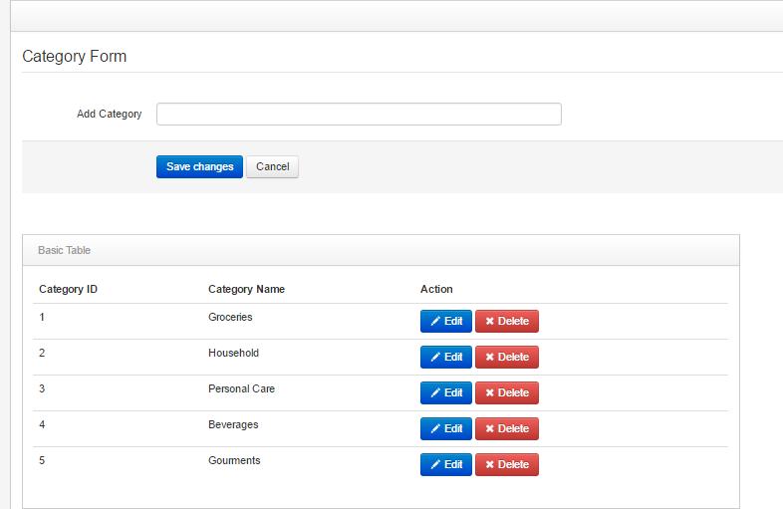

Product Category

Add Product

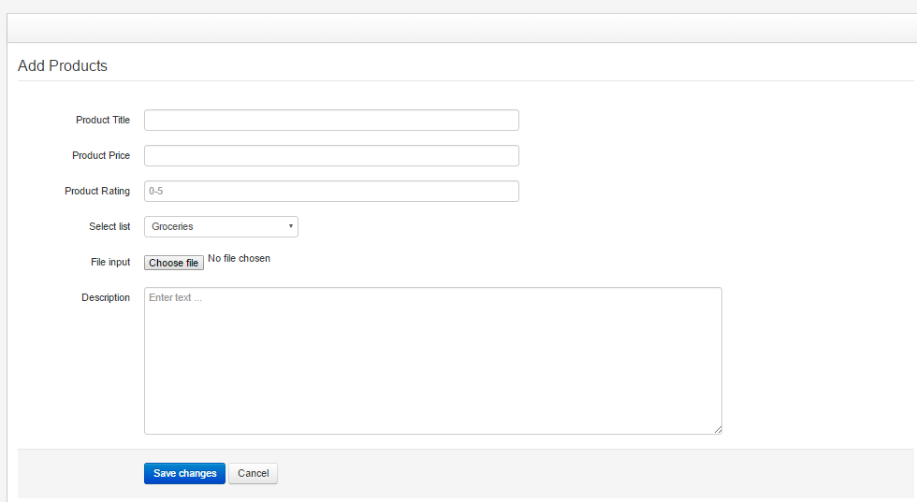

Order

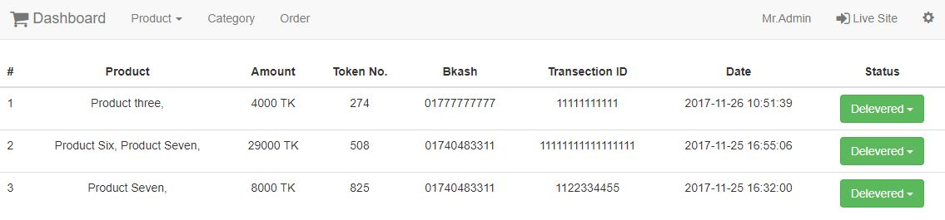

User Profile

Buy products

Cart

Payment

Order page

Chapter 7

**Conclusion**

**7.1 Future Works:**

More features will be added into this application. For example, payment methods such as credit cards will be available on this online store. The future works also enables users to customize features. Providing personalized inbox to the user. Moreover, object-oriented approach will be applied throughout the application.

**7.2 Conclusion:**

The project entitled “Online shopping system” was completed successfully. The system has been developed with much care and free of errors and at the same time it is efficient and less time consuming. The purpose of this project was to develop a web application and an android application for purchasing items from a shop.

This project helped us in gaining valuable information and practical knowledge on several topics like designing web pages using HTML & CSS, usage of responsive templates, designing and management of database using MySQL. The entire system is secured. Also the project helped us understanding about the development phases of a project and software development life cycle. We learned how to test different features of a project.

This project has given us great satisfaction in having designed an application which can be implemented to any nearby shops or branded shops selling various kinds of products by simple modifications.

**References**

|  |  |
| --- | --- |
|  |  |
| [1] | https://en.wikipedia.org/wiki/Systems_design |
| [2] | http://www.sooperarticles.com/business-articles/e-business-articles/limitations-online-shopping-840923.html |
| [3] | https://en.wikipedia.org/wiki/Feasibility_study |
| [4] | http://www.uky.edu/~dsianita/695A&D/lecture5.html |
| [5] | https://www.tutorialspoint.com/system_analysis_and_design/system_analysis_  and_design_implementation_maintenance.html |
| [6] | https://en.wikipedia.org/wiki/Implementation |
| [7] | https://www.tutorialspoint.com/system_analysis_and_design/system_ analysis_and_design_overview.html |
| [8] | https://www.codeproject.com/Tips/351122/What-is-software-testing-What-are-the-different-ty |
| [9] | https://en.wikipedia.org/wiki/Software_testing |
| [10] | http://www.ofnisystems.com/services/validation/functional-requirements/ |
| [11] | https://reqtest.com/requirements-blog/what-are-non-functional-requirements/ |
| [12] | https://www.ibm.com/support/knowledgecenter/en/ssw_aix_71/com.ibm.aix.performance/  doc_perf_reqs.html |
| [13] | https://en.wikipedia.org/wiki/PHP |
| [14] | https://en.wikipedia.org/wiki/JavaScript |
| [15] | https://www.lucidchart.com/pages/data-flow-diagram |
| [16] | https://en.wikipedia.org/wiki/Database_design |